Supporting Information

Delay Tumor Growth Properties of LA-PEG-G Molecule and Its' Application as Drug Carrier
Guangcheng Wei*,†, Meixiu Xin†, Hao Wang, Yehong Huo, Wei Hu, Jigang Jiang, Lei Wang, Liying Ma, Miaomiao Yan, Chunhua Wang*
Department of Pharmacy Science, Binzhou Medical University, Yantai, 264003, China
† These authors are equal to the contribution of this work.
*Correspondence authors E-mail: weiguangcheng2004@126.com; chhuawang2018@126.com

Contents
- Synthesis and Characterization of LA-PEG-G molecules
1.1 Thin layer chromatography
1.2 FT-IR spectrum of LA-PEG-G molecules
1.3 NMR spectrum of LA-PEG-G molecules
1.4 MS spectrum of LA-PEG-G molecules
- CAC determination of LA-PEG-G aggregates
- Cell uptake assay with flow cytrometry
- Tissue Sections

- Synthesis and Characterization of LA-PEG-G molecules
1.1 Thin layer chromatography
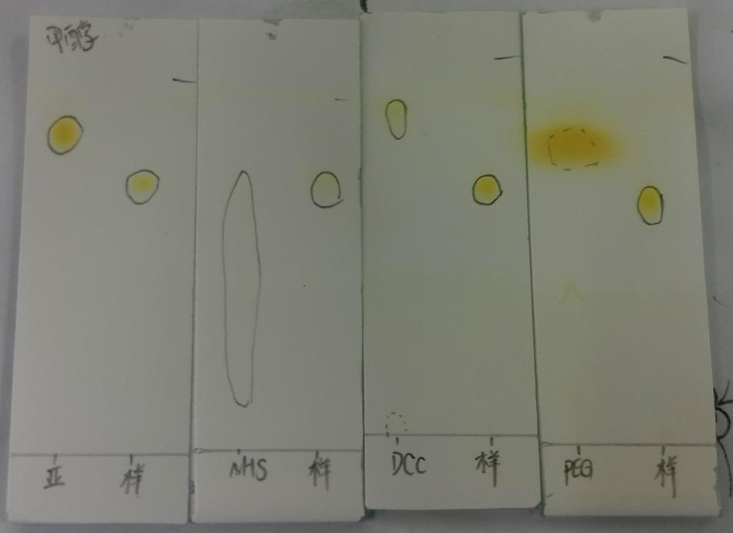
Figure S1 Thin layer chromatography of LA-PEG-G, LA, NHS, DCC and PEG molecules.

1.2 FT-IR spectrum of LA-PEG-G molecules

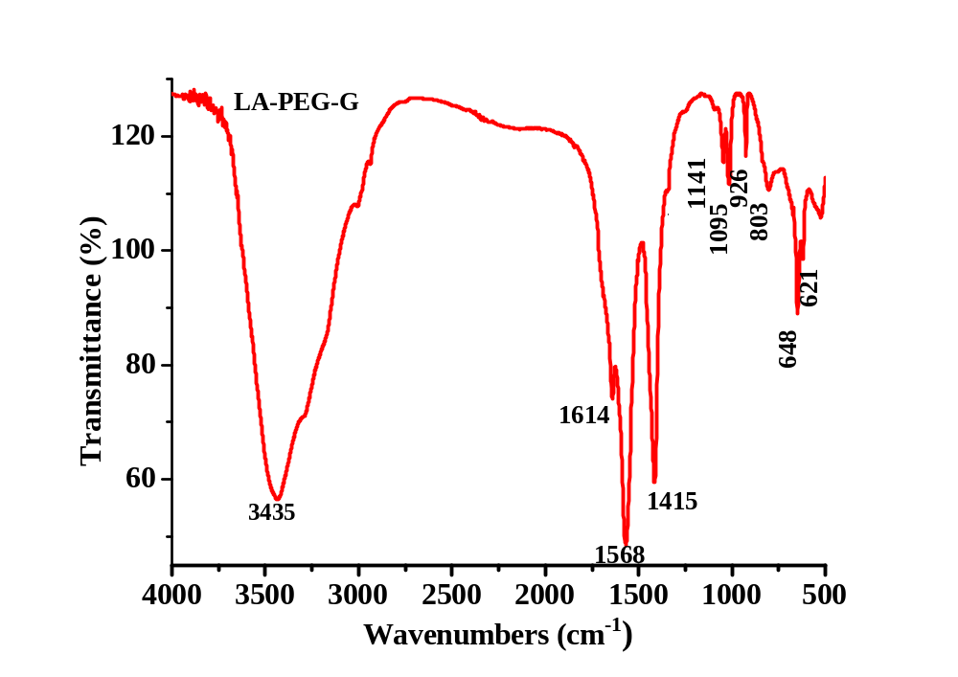
Figure S2 The FT-IR spectrum of LA-PEG-Gmolecule

1.3 NMR spectrum of LA-PEG-G molecules

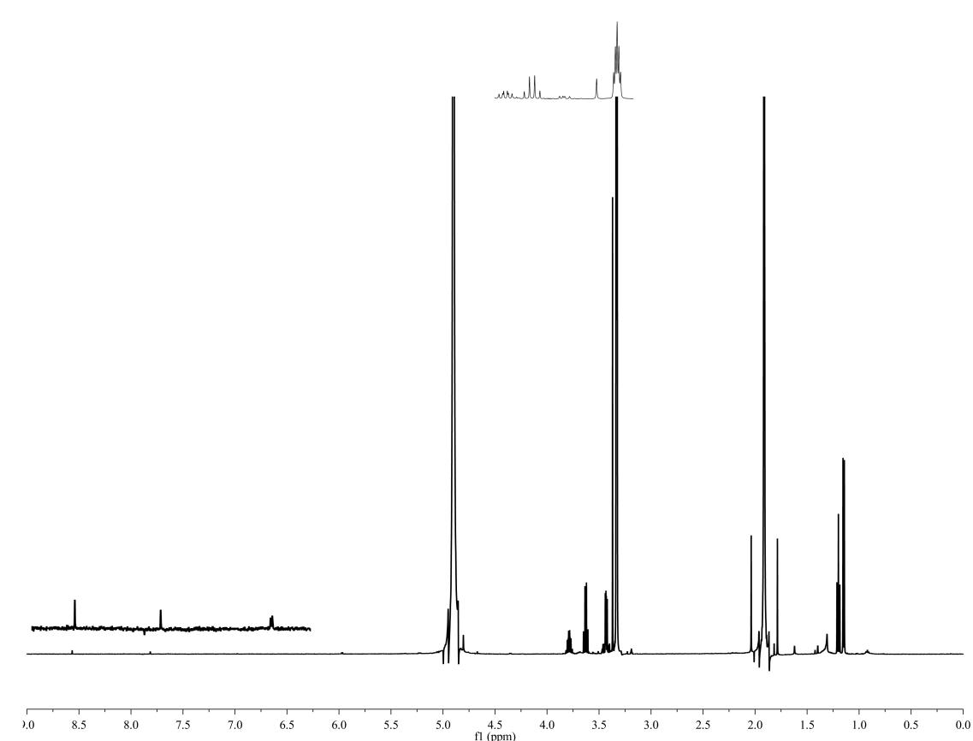
Figure S3 ¹HNMR spectra of LA-PEG-G molecule

¹H NMR (500 MHz, MeOD). δ 8.56 (s, 1H, -C=C-CO-NH-), 7.81 (s, 1H, -CO-NH-), 5.58 – 4.40 (m, 4H, -COO-CH₂-, -O-CH-N-), 4.900 (q, 2H, -N=C-NH₂), 3.805-3.770 (m, 4H,-O-CH₂-CH₂-), 3.63 (m, 6H,-CH₂-CH=CH-CH₂-CH=CH-CH₂-), 3.37-3.334 (m, 4H,CH₃-CH₂-CH₂-), 1.199(t, 2H, =CH-CH₂-C=).
MALDI-TOF MS (m/z): 964.36 ([M+HCOOH-H]⁻).

1.4 MS spectrum of LA-PEG-G molecules
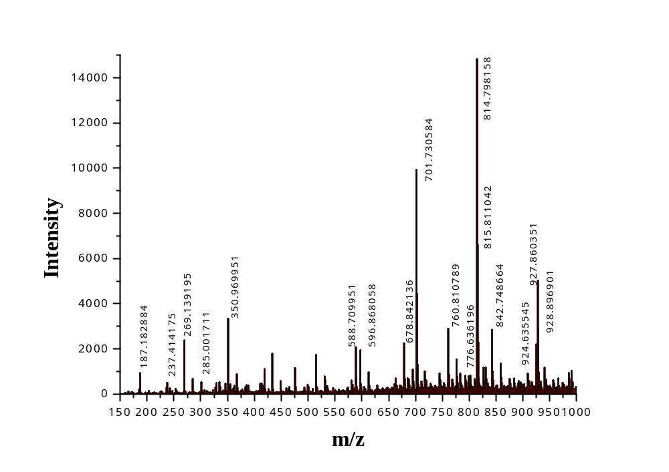
Figure S4 MS spectrum of LA-PEG-G molecule

2. CMC determination of LA-PEG-G molecules

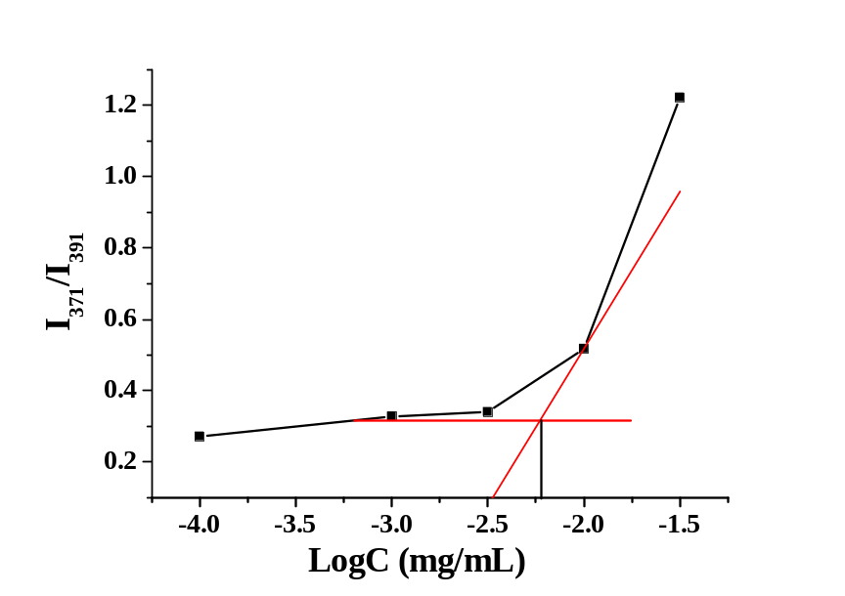
Figure S5 CMC determination of LA-PEG-G molecules in aqueous solution

3. Cell uptake assay with flow cytrometry
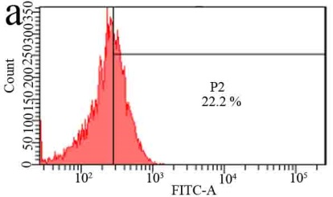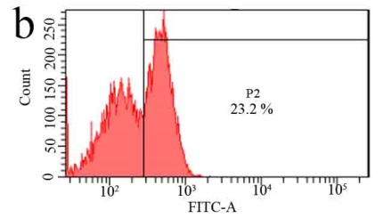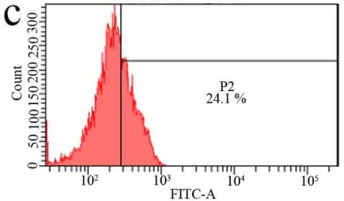
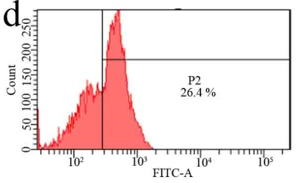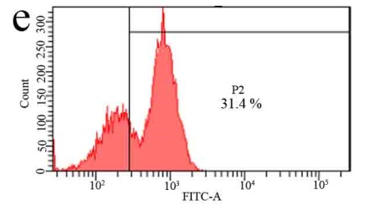
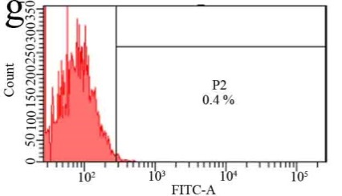

Figure S6 Cell uptake assay with the flow cytrometry. (a) 10μg·mL⁻¹LA-PEG-G-Dox nanomedicine was incubated with HepG2 cell for 2h; (b) 10μg·mL⁻¹LA-PEG-G-Dox nanomedicine was incubated with HepG2 cell for 8h;(c) 10μg·mL⁻¹LA-PEG-G-Dox nanomedicine was incubated with HepG2 cell for 24h; (d)20μg·mL⁻¹LA-PEG-G-Dox nanomedicine was incubated with HepG2 cell for 2h; (e)20μg·mL⁻¹LA-PEG-G-Dox nanomedicine was incubated with HepG2 cell for 8h; (f)20μg·mL⁻¹LA-PEG-G-Dox nanomedicine was incubated with HepG2 cell for 24h; (g) Control group.

4. Tissue sections
 | PBS | Dox | LA-PEG-G aggregate | LA-PEG-G-Dox nanomedicine
Heart | 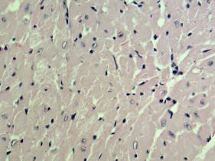 | 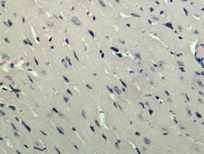 | 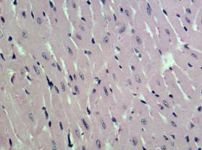 | 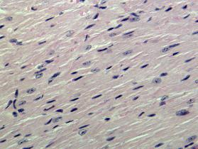
Liver | 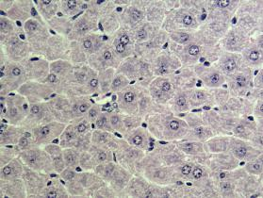 | 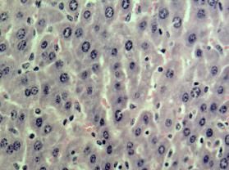 | 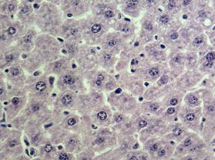 | 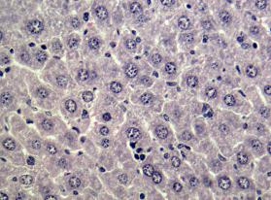
Spleen | 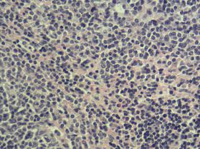 | 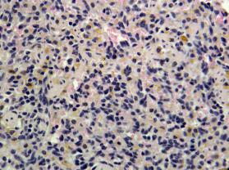 | 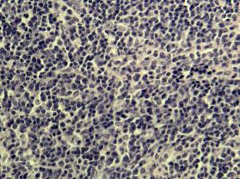 | 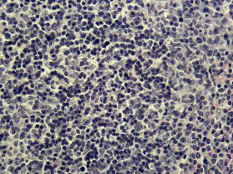
Lung | 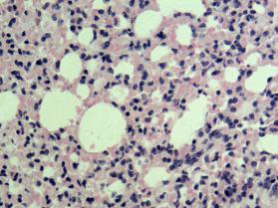 | 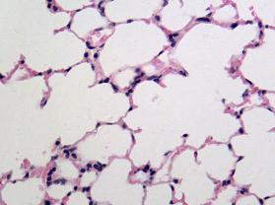 | 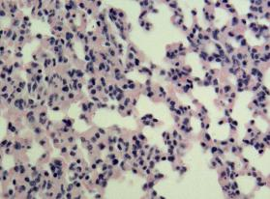 | 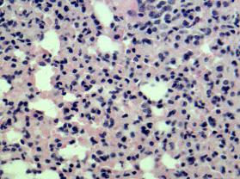
Kidney | 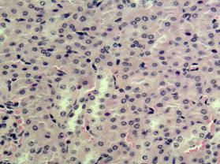 | 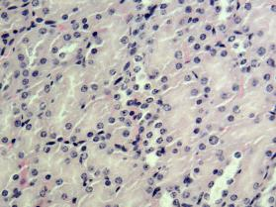 | 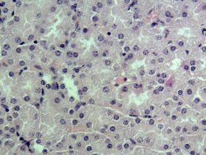 | 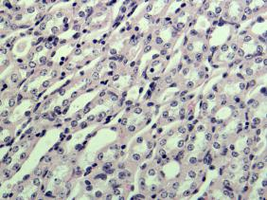

Figure S7 Tissue section of heart, liver, spleen and lung tissue after 19 days of injection of PBS, Dox, LA-PEG-G aggregates and LA-PEG-G-DOX nanomedicine.

